DSA0502 – Query Processing for Data Science
Course Faculty | Dr. B .SHYAMALA GOWRI
Reg. No. | 192324164
Student Name | Sweety Roselin A

LAB PROGRAMS 3 AND 4

3. Write a Pandas program to display the details of jobs in descending order based on job title.
Aim:
To display the details of jobs in descending order based on job title.
Dataset :
%%writefile jobs.csv
job_id,job_title,min_salary,max_salary
IT_PROG,Programmer,4000,10000
PU_CLERK,Purchasing Clerk,2500,5500
SA_MAN,Sales Manager,10000,20000
HR_REP,HR Representative,4000,9000
FI_ACCOUNT,Financial Accountant,4200,9000
MK_REP,Marketing Representative,4000,9000
Code:
import pandas as pd
df = pd.read_csv("jobs.csv")
print(df.sort_values(by="job_title", ascending=False))
Output:
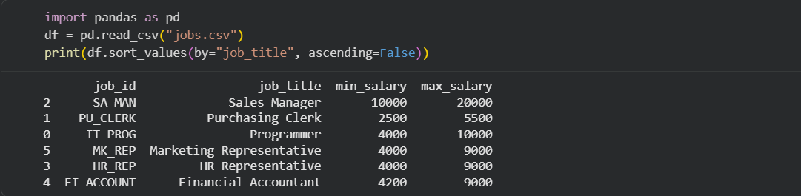Result:
Thus, the job details were displayed in descending order of job title.

4. Write a Pandas program to create a line plot of the historical stock prices of Alphabet Inc. between two specific dates.
Aim:
To create a line plot of the historical stock prices of Alphabet Inc. between two specific dates.
Dataset:
%%writefile Alphabet.csv
Date,Open,High,Low,Close,Volume
2020-01-02,68.72,69.20,68.20,68.90,28132000
2020-01-15,71.20,72.10,70.90,71.80,29500000
2020-02-03,74.50,75.20,73.80,74.90,32000000
2020-02-18,75.80,76.50,75.00,76.10,31500000
2020-03-02,67.50,68.30,66.80,67.90,42000000
2020-03-16,55.20,56.10,54.00,55.80,62000000
2020-03-31,58.60,59.20,57.80,58.90,51000000
2020-04-15,61.30,62.50,60.80,62.00,39000000
2020-04-30,66.10,67.00,65.50,66.70,36000000
2020-05-15,69.80,70.40,69.10,70.00,33000000
2020-05-29,70.90,71.60,70.10,71.30,34000000
2020-06-15,72.40,73.00,71.90,72.80,31000000
2020-06-30,70.80,71.50,70.20,71.10,29500000
Code:
import pandas as pd
import matplotlib.pyplot as plt
df = pd.read_csv("Alphabet.csv")
df["Date"]=pd.to_datetime(df["Date"])
data=df[(df["Date"]>="2020-01-01") & (df["Date"]<="2020-06-30")]
plt.plot(data["Date"],data["Close"])
plt.show()
Output:
Line graph showing Alphabet stock prices.
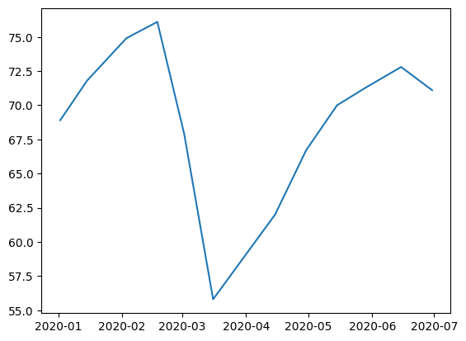
Result:
Thus, the line plot was generated successfully.

